**Unit 5 Project:**

**“Simple Delicious meals from your Fridge and Kitchen”**

It’s a simple and quick site to navigate for quick meals for all busy mums, couples and single folks, with no hassle and stress free delicious meals. The site is mainly to show and guide people to be creative, use one ingredients to cook multiple different meals utilizing what they already have in their fridge and kitchen.

**Step 1: Define Audience / Tone**

* Who will visit your site? Potential employers? New clients or customers?

It’s a site to help busy MUMs, couples and anyone out there to cook creatively, in less than 30min. and use what they currently have in their fridge and kitchen

* What can make you and/or your product stand out against your competitors?

Easy to navigate layout, fun and friendly and provide fast results for all the busy mums, couples and anyone who doesn’t have time to go food shopping.

How would you speak to your clientele if you were communicating in person? How could you translate that style and tone digitally?

Extremely calm and using my experience when I was single, married, and now a mum I know what it’s like when it comes to cooking a meal with not enough time. Using an inviting, friendly logo to convey a stress free tone and use contrasting bright and friendly designs.

* What colors represent you or your product?

I am not sure but for now Green, Red, and white for a stress free tone with a bit of light yellow for color and liveliness. I am open to suggestions.

* What images illustrate your message?

Right now it’s this below:

* 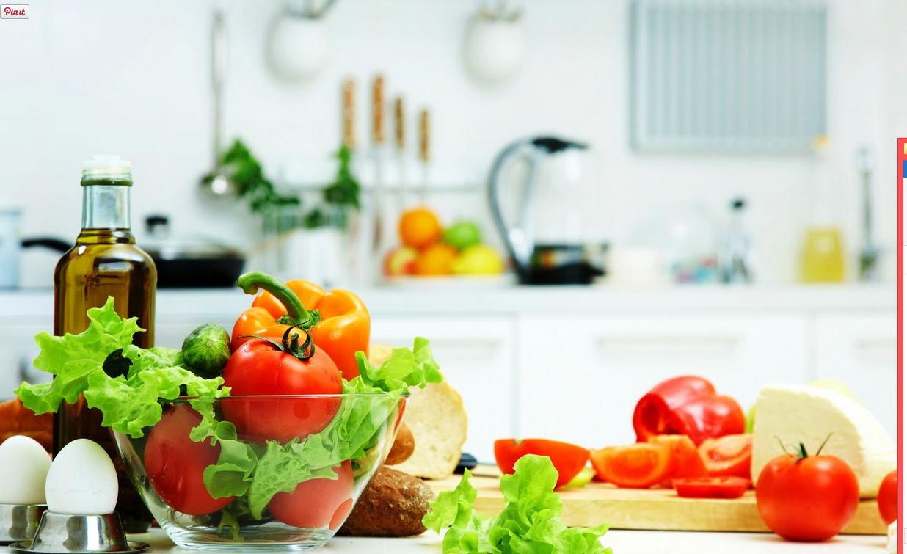

**Step 2: Define Site Structure**

What are the three-to-five pages titled?

Home, Recipes, About, Contact, Blog

What will be the purpose for each? Information

What should each page contain? Will there be textual content? Or just images?

Text and Images

**Home**

“Simple delicious meals from your FRIDGE and KITCHEN”

Contains:

* Navigation Bar
* Sign up
* login
* Ingredients
* How To

**Reccipes:**

* Navigation Bar
* Images of shared recipes

**About:**

* Navigation Bar
* Title ”About”
* Image
* Paragraph

**Contact:**

* Navigation Bar
* Title “Contact me”
* Image

**Blog:**

* Navigation Bar
* Title”Blog
* paragraph